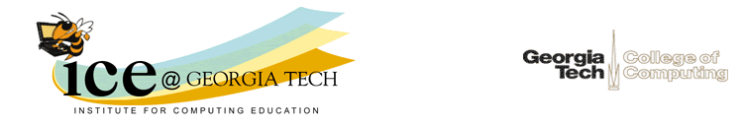

Dear Parents of [Name],

Your son's score on the PSAT shows that he could excel in an Advanced Placement Computer Science course. Why should he consider a course in computer science? Would he be interested in a high paying job? Would he like a job where he can create mobile applications, video games, cool special effects, or new devices? Computers are crucial to our way of life. They have changed the way we communicate, work, and play. AP Computer Science courses can help him get started in an exciting and rewarding career in computing.

The United States Department of Labor predicts computing jobs to be among the fastest growing through 2020. In fact, they expect there to be over 1.4 million jobs in the U. S. in this field by 2020, but only expect U. S. colleges and universities to graduate enough people to fill less than half of those jobs. Students who graduate with a computer science degree have either the highest starting salary or the 2nd highest of any 4-year degree.

Even if your son isn't thinking of a career in computing, an Advanced Placement Computer Science A or CS Principles class can help him. Many fields will require him to take a computer science class in college, especially any science, engineering, or math fields. At Georgia Tech, all students must pass a course in computer science or place out with a score of 4 or 5 on the AP CS A exam! Students who have prior programming experience do much better in introductory computing courses. AP Computer Science A and CS Principles both count as a science for high school graduation and as a science or math for entry into Georgia colleges and universities.

If your high school doesn't offer Advanced Placement Computer Science, contact the principal and ask her or him to consider adding the course through the Georgia Virtual High School. Or consider sending your son to a computing summer camp. Georgia Tech also offers Project Rise Up 4 CS to help under-represented minorities pass the AP CS A exam. It offers twice a week webinars and in-person sessions at Georgia Tech.

Thank You,

Barbara Ericson
Director, Computing Outreach
College of Computing
Georgia Tech

